ENVIRONMENTAL MANAGEMENT

ABSTRACT:

This paper is based on a survey to analyze the current Environmental Management System (EMS), or Green Manufacturing (GM), practices in Hong Kong. The survey focuses, in particular, on the investigation of: the critical factors that most companies have considered in implementing the GM or EMS;

the benefits that the companies have targeted in implementing the GM/EMS; the business activities that the companies have carried out in striving for the targeted benefits; the business benefits attainable in the implementation of the GM/EMS.

The study results show that most of the companies used in the survey have a positive attitude towards the implementation of the GM/EMS. The majority of them also consider that GM/EMS can effectively strengthen their competitiveness in business

INTRODUTION:-

The increasing environmental consciousness of the public, the statutory requirements due to government policies and regulations, and pressures from organized groups are traditionally considered to be the factors that sway companies to adopt a Green Manufacturing (GM) or an Environmental Management System (EMS) policy [1].

* The needs for environmental protection (such as waste minimization, pollution prevention, energy conservation and other health and safety issues) have been widely publicized.
* An increasing number of firms recognize that adopting a GM/EMS is an integral part of the business strategy.
* Adoption of a GM helped to decrease waste and pollution generation [2],
* whereas implementing the EMS provided an effective guidance for companies to simultaneously develop and review their business practices towards both corporate and environmental goals [3].
* There are several GM practices and EMS standards currently adopted by different regions and countries throughout the world [4].
* The Eco-Management and Audit Systems, CSA-Z750-94, BS 7750 and ISO 14000 series are typical examples [5], [6].
* These standards are designed to help organizations, regardless of their size and business type, to develop a formalized management process with the objective of evaluating and improving their environmental and safety performance [7].
* The GM/EMS program in Hong Kong is relatively new; not much information about its implementation results is available.
* The investigation reported in this paper was based on the eleven companies that had participated in the ISO 14000 EMS Pilot Program organized by the Hong Kong Productivity Council in 1995.
* One of the objectives of this investigation is to identify the critical factors/sub-factors, benefits and business activities that a company may have considered or targeted in the implementation of the GM/EMS program.
* Another objective is to discover what activities contributed to a successful GM/EMS program. The benefits that are recognized by these companies for the implementation of the program are also to be determined.

LITERATURE SERVEY:-

NAME:-MOHAMMAD B.MEMON

Published: September 25, 2022 (see history)

DOI: 10.7759/cureus.29558

Cite this article as: Memon M B, Chadda N, Dahhan A, et al. (September 25, 2022) Refractory Hypotension: A Detailed Case Discussion and Current Literature Review. Cureus 14(9): e29558. doi:10.7759/cureus.29558

NAME:- NASEEM S.MILLER

On Sept. 28, the White House is hosting a conference on hunger, nutrition and health — the second conference of its kind in five decades — and introducing a 40-page national strategy as a roadmap toward the goal of ending hunger and increasing healthy eating by 2030.

NAME:-DR.NAGHAM MAHMOOD ALIJAMALI

Dr. Nagham Mahmood Aljamali1\* , Dr. Aseel Mahmood Jawad2 , Anaam Jawad Alabbasy3, Dr. Layla Ali Mohammed Salih4 1,4Department of Chemistry, College of Education for girls, kufa university, Iraq. 2College of Medicine, General Surgery Department, Iraq. 3Department of Biology, College of Education for girls, kufa university, Iraq.

OBJECTIVES:-

The main objectives of the environmental management system are to prevent pollution, meet compliance obligations and enhance conditions of the environment.

A systematic approach to environmental management can provide the organization with information to build success over the long term and create options for contributing to sustainable development by:

protecting the environment by preventing or mitigating adverse environmental impacts;

- mitigating the potential adverse effect of environmental conditions on the organization;

- assisting the organization in the fulfilment of compliance obligations;- enhancing environmental performance;

- controlling or influencing the way the organization’s products and services are designed,manufactured, distributed, consumed and disposed by using a life cycle perspective that canprevent environmental impacts from being unintentionally shifted elsewhere within the life cycle;

The use of environmental management tools allows institutions to anticipate and to avoid problems in a proactive rather than reactive way. They assist with analysis and reporting of performance and with day-to-day management, which requires timely feedback to make appropriate adjustments.

This free course began by approaching environmental management as a way of thinking about and managing changing human–environment relationships in their many different arenas and contexts, and

drawing on systems ideas to explore how those relationships are understood and managed over time.It firstly challenged the ways that you may think about environment and management and then explored different ways of thinking about organisations including as a system,

why a focus on organisations is key to environmental management and some of the historical aspects of environmental management in relation to organisations.

You have also had an opportunity to think about the links between an organisation and its environment, and some aspects of voluntary and compulsory approaches to environmental management.

PROBLEM IDENTIFICATION ENVIRONMENT:-

Environmental management problems are often complex and uncertain. A formal process with proper guidance is needed to understand the issues, identify sources of disagreement, and analyze the major uncertainties in environmental problems. This course will present a process that fo...

Identifies the more representative problem-solving models in environmental education. Suggests the addition of a strategy for defining a problem situation using Soft Systems Methodology to environmental education activities explicitly designed for the development of critical thinking. Contains 45 references. (JRH

Environmental problem is a real problem that occur in students daily life. Junior high school students perception about environmental problem is interesting to be investigated. The major aim of this study is to explore junior high school studentsâ€™ perception about environmental problems around them and ways to solve the problem.

Water pollution:-

The following review attempts to understand water pollution from a chronological perspective, representing the shift in sources of pollutants, namely from purely examining sewage to the contemporary issues of microplastics before recognising the research of naturally occurring factors affecting the overall water quality. Lastly, we review the change of focus surrounding the impacts of bad water pollution on health with specific regards to disease transmission.

Pollution Water resources are considered to be polluted when the physical, chemical and or biologicalcharacteristics of water are altered to such an extent that the utility for any reasonable purpose becomes dysfunctional or its environmental value is demonstrably depreciated.

COMPONENTS OF WATER:-

Temperature:

Disturbances of temperature, largely due to the disposal of hot water into adjoining water supplies can disrupt the local aquatic ecosystems. Typically, such action is derived from nuclear power and other power generation processes as they require intensive water coolantsystems. Little is discussed of thermal pollution before the 1900’s, though since world war 2, electric utility requirements have raised considerably in demand and nuclear power stations had started to become viable sources drawing more attention to such issues

pH:

egative log of H+ concentration contained within a sample. It can regulate the effectiveness of enzymatic reactions. A surge of new papers, gravitate around the effects of anthropogenic co2 loading on ocean acidification. (Orr et al., 2005) attempts to identify the changes of aragonite in response to increased carbon dioxide loading and the effects this may have on corals (who maintain external calcium carbonate skeletons)

SOIL POLLUTION:-

Heavy metals:-

The presence of heavy metals in soils can cause it to become highly toxic to human beings. Some metals that can be classified as soil pollutants such as arsenic (As), mercury(Hg), lead(Pb), antimony (Sb), zinc (Zn), nickel (Ni), cadmium (Cd), selenium (Se), beryllium (Be), thallium (Tl), chromium (Cr) and copper (Cu).

Acid rain:-

Acid rain has high levels of hydrogen ions, making it acidic. When this rain seeps into the soil, it can adversely change the soil chemistry. This means the acid rain may negatively affect plants and important microbes that live in the soil; thereby affecting the food chain (e.g., Chen et al., 2012).

Mining:-

Mining activities can affect the soil by causing soil erosion, the formation of sinkholes, or leaching chemicals of the mining process into the soil.

AIR POLLUTION:-

Indore air quality:-

A lack of ventilation indoors concentrates air pollution where people often spend the majority of their time. Radon gas, a carcinogen, is exuded from the Earth in certain locations and trapped inside houses. Building materials including carpeting and plywood emit formaldehyde (H2CO) gas.

Emission factors:-

Air pollutant emission factors are reported representative values that attempt to relate the quantity of a pollutant released to the ambient air with an activity associated with the release of that pollutant. These factors are usually expressed as the weight of pollutant divided by a unit weight, volume, distance, or duration of the activity emitting the pollutant (e.g., kilograms of particulate emitted per tonne of coal burned). Such factors facilitate estimation of emissions from various sources of air pollution

The GM/EMS program in Hong Kong is relatively new; not much information about its implementation results is available.

The investigation reported in this paper was based on the eleven companies that had participated in the ISO 14000 EMS Pilot Program organized by the Hong Kong Productivity Council in 1995.

One of the objectives of this investigation is to identify the critical factors/sub-factors, benefits and business activities that a company may have considered or targeted in the implementation of the GM/EMS program.

Another objective is to discover what activities contributed to a successful GM/EMS program.

The benefits that are recognized by these companies for the implementation of the program are also to be determined

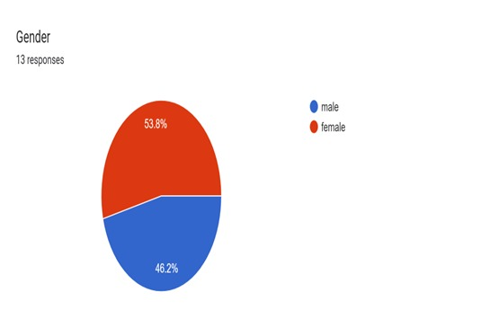 FIG -1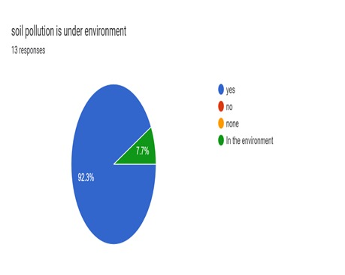FIG -2

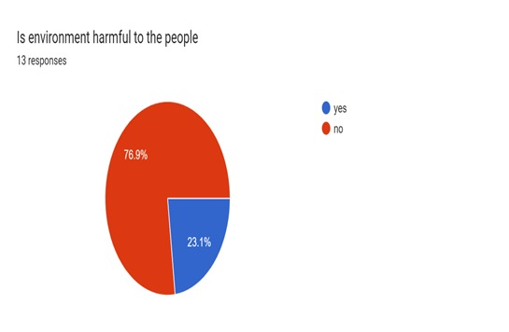FIG -3

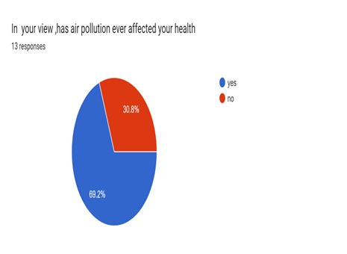FIG -4

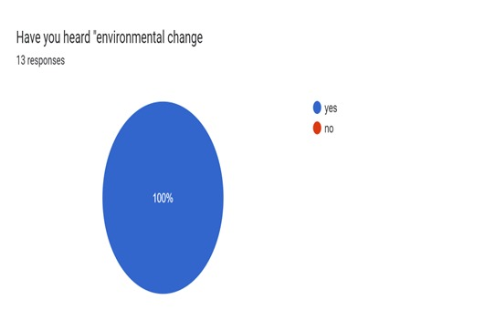FIG-5

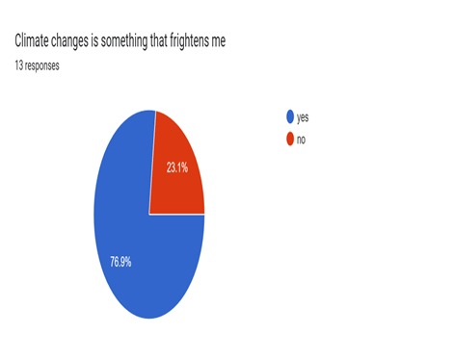FIG-6

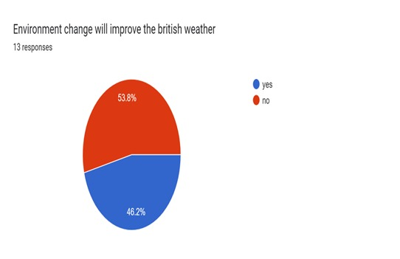FIG-7

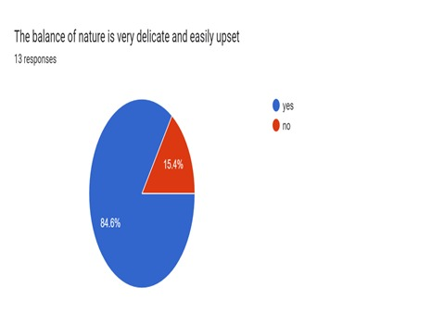FIG-8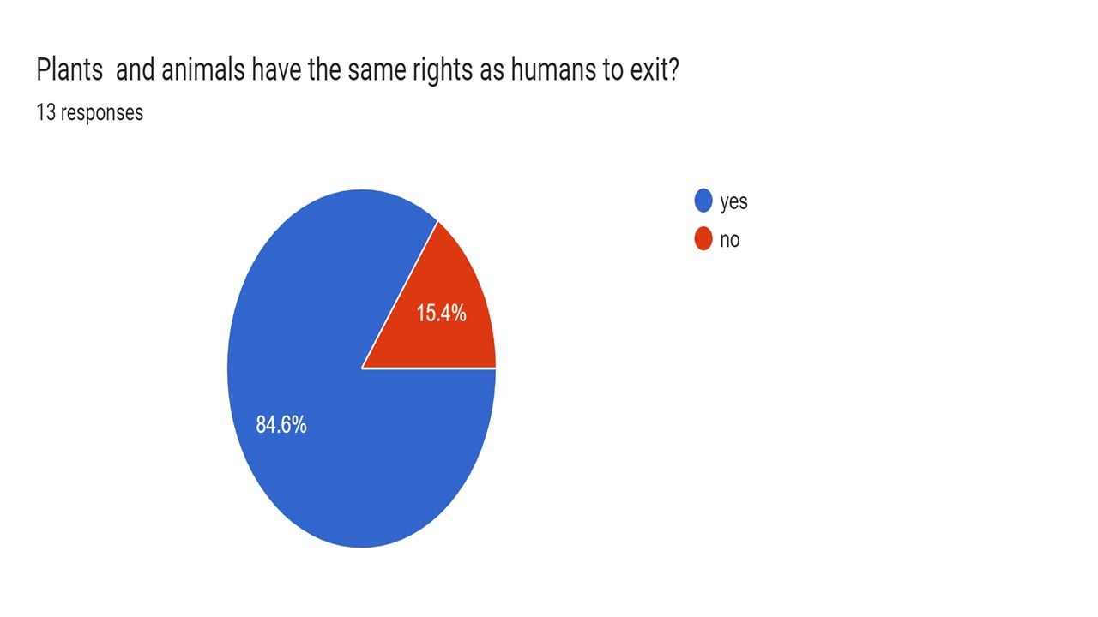FIG-9

CONCLUSION:-

The use of environmental management tools allows institutions to anticipate and to avoid problems in a proactive rather than reactive way. They assist with analysis and reporting of performance and with day-to-day management, which requires timely feedback to make appropriate adjustments.

This free course began by approaching environmental management as a way of thinking about and managing changing human–environment relationships in their many different arenas and contexts, and

drawing on systems ideas to explore how those relationships are understood and managed over time.It firstly challenged the ways that you may think about environment and management and then explored different ways of thinking about organisations including as a system,

why a focus on organisations is key to environmental management and some of the historical aspects of environmental management in relation to organisations.

You have also had an opportunity to think about the links between an organisation and its environment, and some aspects of voluntary and compulsory approaches to environmental management.

REFERENCE:-

Berger, M., Warsen, J., Krinke, S., Bach, V. and Finkbeiner, M. (2012) ‘Water footprint of European cars: potential impacts of water consumption along automobile life cycles’, Environmental Science & Technology, vol. 46, no. 7, pp. 4091–99.

Brown, M. (2012) ‘Water stress hurting more than 50% of global companies, CDP says’, Bloomberg, 23 October [Online]. Available at http://www.bloomberg.com/ news/ 2012-10-23/ water-stress-hurting-more-than-50-of-global-companies-cdp-says.html (Accessed 5 June 2013).

Chernobyl Forum (2006) Chernobyl’s legacy: health, environmental and socio-economic impacts [Online], Vienna, Austria, International Atomic Energy Agency. Available at http://www.iaea.org/ Publications/ Booklets/ Chernobyl/ chernobyl.pdf (Accessed 7 June 2013).

https://www.open.edu/openlearn/nature-environment/environmental-management-and-organisations/content-section